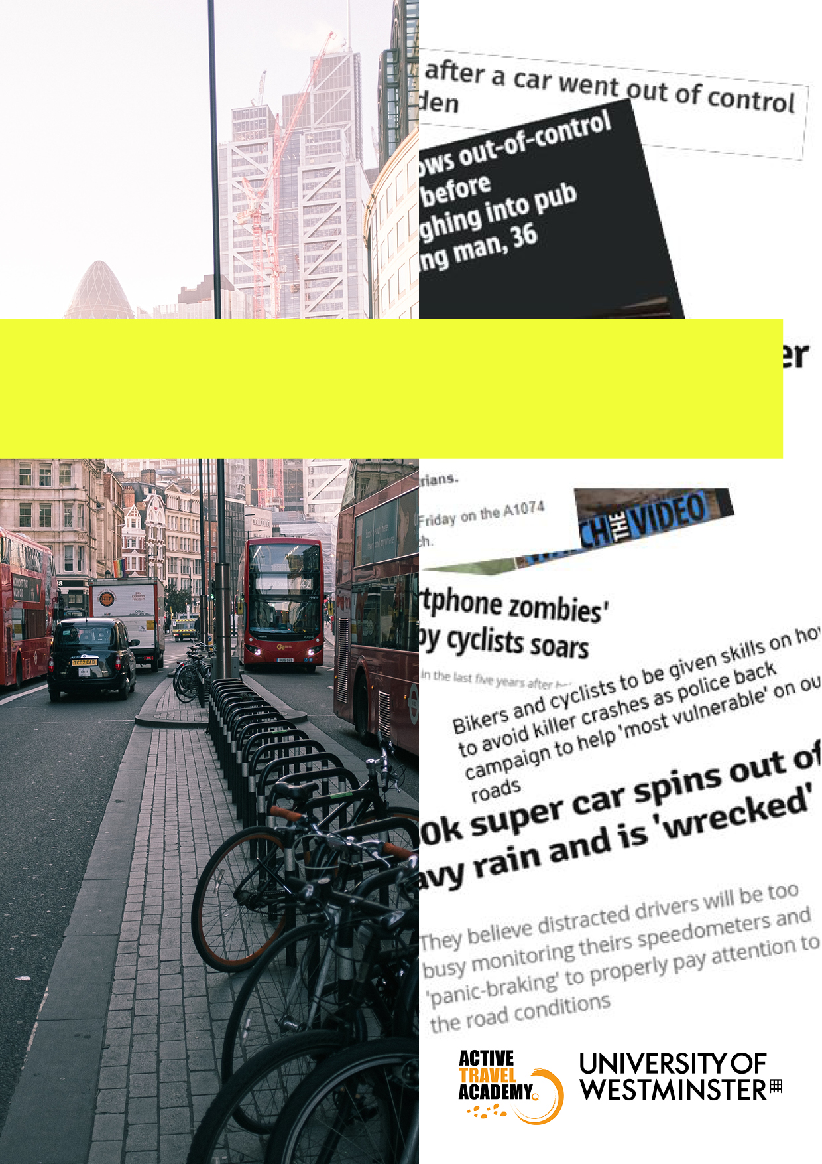

MEDIA GUIDELINES FOR
REPORTING ROAD COLLISIONS



CONTENTS

3. Introduction – why we need guidelines
4. Forward by David Davies, PACTS
5. Ten points for reporting on road collisions
7. Examples
8. Good journalism changes attitudes
9. Journalist Resources
11. Supporters

ROAD COLLISION REPORTING GUIDELINES
– WHY WE NEED THEM

Every year 1700 people die on UK roads, with tens of thousands more people seriously injured. Over a million people are killed worldwide each year, with road collisions the biggest killer of young people aged 5-29.
Accurate reporting of these deaths and injuries matters. There is growing evidence that poor reporting can confuse or misdirect concern, obscure the solutions, and even engender aggression.
Good reporting can help us better understand the problems and potential solutions. Transport can both aggravate and address some of society’s pressing challenges; from access to work, education, leisure and social opportunities, to climate change, physical and mental health, and air pollution. Through coverage of issues such as road collisions, good journalism shines a light on them, improving accuracy and clarity without sacrificing word counts.
While many journalists already follow good practice, there is always room for improvement. This could mean describing all human actors in collisions neutrally, such as “driver and pedestrian in collision”, rather than, say, “pedestrian hit by car”, which research shows unintentionally shifts focus to the only named human actor, and implicitly attaches a degree of blame.
It could mean providing crucial context in coverage of road collisions, which research tells us is key in helping us understand wider issues and trends. By including local or national crash statistics, for example, publishers can avoid treating crashes as isolated incidents. Research suggests portraying crashes in that way blocks debate about possible wider causes, such as street design features that tend to put pedestrians at higher risk.
It could also mean avoiding use of the term ‘accident’, which risks making crashes seem inevitable and unavoidable, or avoiding ‘grouping’ road users by negative characteristics, to protect those road users from becoming targets of aggression.
Most road collisions are avoidable. After concerted efforts since 1997, by 2009 Sweden halved road deaths via improved street design, policing and legislation, protecting the most vulnerable on the streets; a process known as Vision Zero.
In the UK, as in many European countries, road fatalities are no longer in decline. Road danger and traffic violence, even where no injury occurs, can make people feel unsafe on the streets, reducing their choices and quality of life, while the impacts of road trauma can last a lifetime.
These guidelines are intended to provide an industry standard by consensus, acting as a supplement to existing industry codes of practice to help journalists, publishers and broadcasters produce the highest standards of reporting on road collisions. They have been produced in collaboration with academics, road safety and policing organisations, and with journalists, broadcasters and editors in the media.
“It was the subtle implications of blame that annoyed and upset me when my friend was killed. He was described as wearing ‘dark clothing’ – and then the article just moved on. It was completely irrelevant, not least because the driver was later found to have been falling asleep at the wheel so it wouldn’t have mattered how bright his clothing was.”
Kathryn Shaw, Living Streets

FORWARD BY DAVID G DAVIES
Executive Director Parliamentary Advisory Council for Transport Safety (PACTS)

TV presenter Nick Ross was famously challenged by BBC colleagues to make a programme about road safety that was interesting. In the event, the documentary The Biggest Epidemic of Our Times, was watched by millions and credited with changing the public debate.
Yet 40 years on, the challenge for journalists remains. Road deaths are often too commonplace to be “news” while, as a feature, road safety can seem worthy but dull. If there is an interesting hook, it is often because it is not representative.
The public are ambivalent and contradictory. They readily complain about dangerous drivers and irresponsible cyclists and generally support tougher sentences – even life – for those guilty of causing road death. Yet the same people may object to lower speed limits or blocking rat runs for traffic, and take a relaxed attitude to their own safety and that of others.
Some users, however, feel the risks acutely – parents whose children are walking to school or learning to drive, cyclists mixing with busy traffic, and older drivers who find high speeds, busy traffic and new road layouts increasingly challenging. Bereaved families never forget and may never fully recover. Statistics are irrelevant to them. It is what they feel that counts.
Journalists face a challenge and a dilemma. Death and injury on the road is not new but still matters. After suicides, road collisions are the biggest killer of otherwise healthy people in the UK; and for those aged 5 to 25, the biggest killer bar none.
When a collision occurs (or should that be crash, but preferably not accident?), people want to know why and who was to blame. Yet the facts can be complicated and take months to fully emerge, if ever, by which time the story has died.
Journalists also have a responsibility. The language and tone of the debate can affect road user psyche and ultimately behaviour, particularly towards minority outgroups.
PACTS welcome these media guidelines which acknowledged the challenges and the complexity and point the way to balanced and constructive reporting. If we are to achieve a fairer, healthier, more environmentally friendly society post-covid, we need roads where everyone is and feels safe.
“What has frustrated me over the years is the inconsistent way in which the same publication might report on issues relating to road safety.
“I have seen newspapers complaining about speed cameras and the ‘war on motorists’ on one page, whilst on another page in the same edition there is a report on sentencing of a road death case where the defendant is portrayed as a monster whose sentence is wholly inadequate, despite the fact that the main reason they were convicted was that they were speeding at the time they collided with the deceased.
“As well as individual reporting being important, I think editors have a duty to ensure a consistent approach.”
Professor Sally Kyd,
Leicester Law School

ROAD COLLISION REPORTING GUIDELINES
– TEN POINTS FOR PUBLISHERS

- At all times be accurate, say what you know and, importantly, what you don’t know. Often emergency services will release scant information and key details won’t emerge until an inquest or court case. If further details do emerge, do update stories with the facts.
- Avoid use of the word ‘accident’ until the facts of a collision are known. Most collisions are predictable and before an enquiry or court case the full facts are unlikely to be known. It is particularly important to avoid the word when someone has been charged with driving offences. Using ‘crash’ or ‘collision’ instead leaves the question of who or what is to blame open, pending further details.
- If you’re talking about a driver, say a driver, not their vehicle. This is particularly important when describing actions such as speeding, or leaving the scene of a crash. If little is known in the aftermath of a crash, initially describe human actors as e.g., ‘driver and cyclist in collision’ or ‘two drivers in collision’, before mentioning vehicles. Where details of the crash are known, or one human actor is clearly particularly vulnerable (or slow-moving), such as pedestrians or children, publishers may find it more accurate to say one person ‘hit’ the other, e.g., ‘driver hit a child in a pushchair’, or ‘driver hit a man crossing the road’.
- Consider the impact on friends and relatives of publishing collision details. People deal with grief differently, and publishers should check with families when publishing injury detail.
- Treat publication of photos with caution, including user generated footage or imagery. Photos including number plates, or anything related to victims at the scene of a crash could cause distress to friends and relatives, particularly if they aren’t yet aware of the collision. Be wary of publishing footage that could have been taken from behind the wheel, that may be seen to endorse mobile phone use while driving.
- Be mindful if reporting on traffic delays not to overshadow the greater harm, of loss of life or serious injury, which could trivialise road death. Remember emergency response staff may close a road following a collision while trying to save a life.
- Journalists should consider whether language used negatively generalises a person or their behaviour as part of a ‘group’. Research shows that if people see a road user, such as cyclists, as an outgroup, or less than human, they are more likely to act aggressively towards them on the roads. Violence on the roads lies on the same continuum as everyday, normalised discrimination tolerated by the public. Be mindful that language insinuating there is a ‘war’ or ‘battle’ on the roads risks in itself inflaming tensions.
- Coverage of perceived risks on the roads should be based in fact and in context. Larger, faster vehicles have a greater potential to cause injury and death, while those on horseback, on foot and cycles are more likely to be seriously injured in a collision - figures that are reflected in road casualty figures. Providing context, such as local or national collision trends is particularly powerful in helping readers understand the scale of a problem, and avoids portraying incidents as isolated, when this is often not the case. High visibility clothing and helmets don’t guarantee users safety, and mention of these elements has a powerful impact on readers, encouraging them to apportion blame before the full facts are known.

- Avoid portraying law-breaking or highway code contravention as acceptable, or perpetrators as victims. An example of this is stories of speed camera use somehow ‘targeting’ road users, or causing danger on the roads. Speed is a major contributory factor in road collisions, serious injury and death on the roads and media attention for targeted enforcement of speeding, distracted driving, and impaired driving can increase awareness of—and support for—those efforts, research shows. Covering outcomes of investigations or prosecutions allows the public to see justice in action.
- Road safety professionals can help provide context, expertise, and advice on broader issues around road safety. Journalists aren’t expected to be experts in all fields, and it is good practice if reporting on road collisions to maintain regular contact with those experts, who can provide context or viewpoints emergency services may not mention. See our list of journalist resources and contacts on page nine.
“I was run over in 2014 and my left leg was amputated as a result of the collision. I narrowly survived. This was the beginning of my journey campaigning for road danger reduction. A headline at the time read:
‘A cyclist who was nearly killed and lost her leg after she was hit by a skip lorry has hugged and forgiven the driver who was fined £750 for his role in the accident.’
“Reading it you’d be forgiven for assuming that I should be hugging the skip lorry instead of the driver; it reads as though the skip lorry is to blame for the crash. And why am I forgiving someone if it was an accident? And what would the role of the driver be, given it was an accident? What’s he
even being fined for?”
Victoria Lebrec, RoadPeace
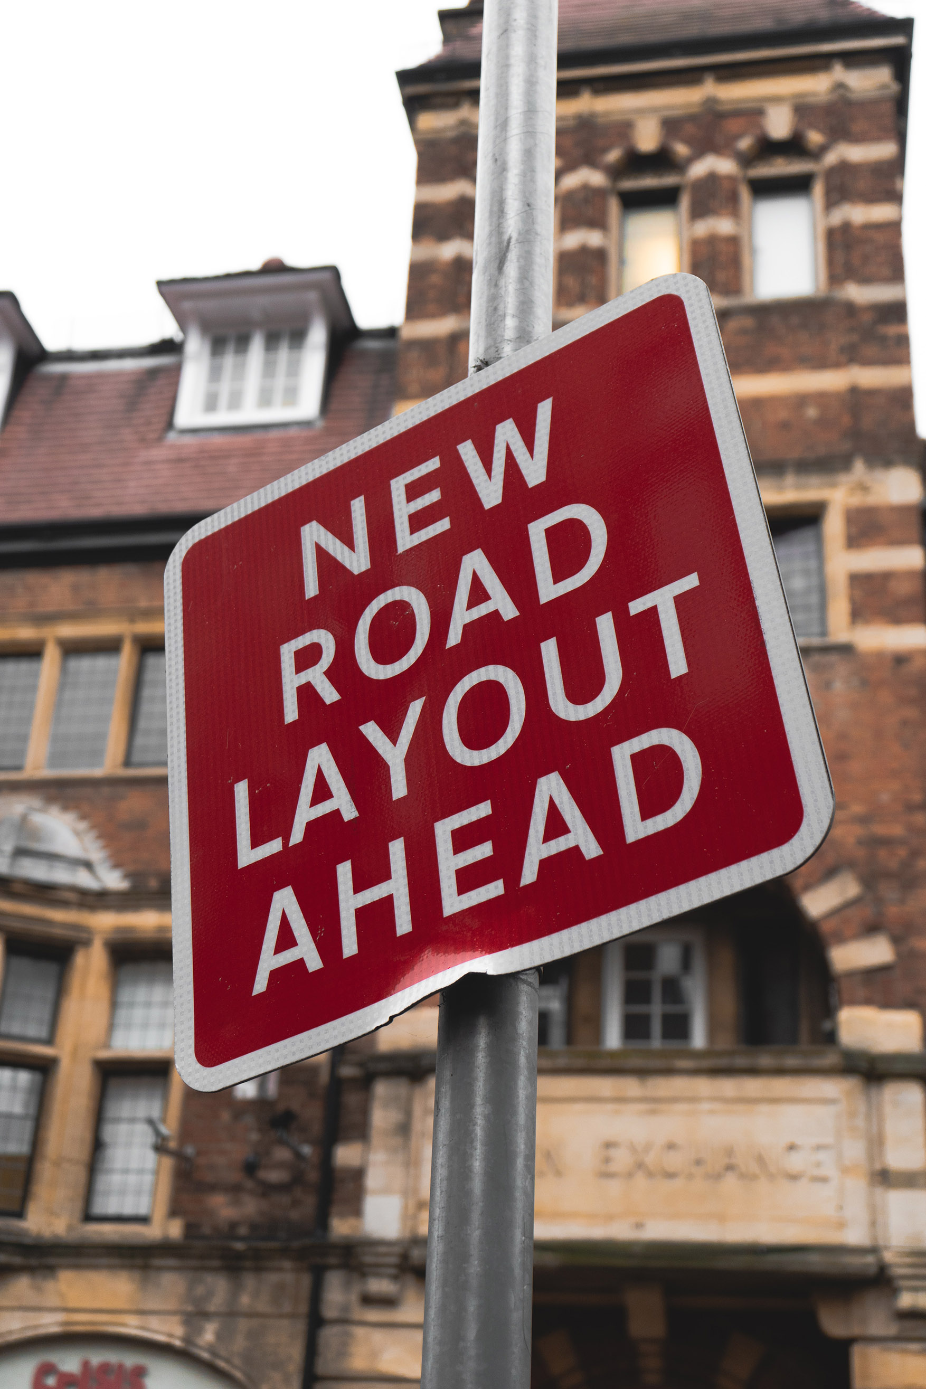

EXAMPLES

INSTEAD OF | CONSIDER | REASONING
Two people have been injured following an accident on Broadway | Two people have been injured following a  collision/incident/crash on Broadway | Replace ‘accident’ with the more neutral incident, collision, or crash
Person injured after Audi crashes into lamp post | Person injured after driver crashes into lamp post | Replace ‘car’ with driver
After hitting one person, the BMW then crossed the road before mounting the kerb, and forced members of the public to take evasive action after it drove along the pavement | After hitting one person, the BMW driver then crossed the road before mounting the kerb, and forced members of the public to take evasive action after they/he/she drove along the pavement | Replace ‘car’ with driver, and inanimate ‘it’ with ‘they/he/she’
Tributes left at scene after infant killed in pram crash | Tributes left at scene where infant in pushchair killed after being hit by driver | Includes mention of driver, instead of implying a ‘pram’ crashed on its own
A teenager was taken to hospital following a crash between a car and a cyclist | A teenager was taken to hospital following a crash between a driver and a cyclist | Altered to include both human actors equally, instead of one person and one vehicle
Oaktree Road was shut for two hours after a two-car crash left three people injured | Three people were injured in a two-car crash that closed Oaktree Road for two hours today | Initial focus on injury and collision, instead of delays
A woman was badly injured when a car crashed into her home. Police said a man, 21, was arrested on suspicion of drink driving | A woman was badly injured when a driver crashed into her home. Police said a man, 21, was arrested on suspicion of drink driving | Replacing ‘car’ with driver

GOOD JOURNALISM CHANGES ATTITUDES
Chris Myant, National Union of Journalists’ Ethics Council

My cousin was killed in a Wrexham industrial estate. He had parked his car and got out of the vehicle just as the swinging side panel of a trailer being driven along the road hit him from behind. It caused ‘unsurvivable head injuries’. The pins meant to hold that panel in place were poorly fixed and it came adrift after the driver had set out on their journey.
Some months later, the Daily Post in North Wales reported on the driver’s trial in court. Over several days, the paper’s staff provided full-page coverage of the arguments around whether or not the driver should be seen as legally responsible for how the trailer panels were secured. Was it reasonable to say that they should have checked in detail before starting the voyage? What was the technical evidence of the state of those pins? Why did the driver not see that the panel had swung loose?
Those reports have haunted me ever since, particularly when strapping a load on the roof of my own vehicle, filling a trailer with loose bits and pieces or when driving behind someone with what looks like half a dozen bikes hanging off the back of a hatchback by a couple of thin straps. They come into my mind every time I cycle and a lorry rushes by, its ratchet straps flapping loose.
It was good, professional court reporting that brought out the importance of the theme of professional responsibility, whether of someone on the public highway or of someone commanding an audience in the media.
Acting recklessly is something we all know is wrong. Acting without full care and caution is more easily done, more easily excused and yet can be more costly in terms of consequences for others as well as ourselves.
Enabling us all to be less of a danger to others when out and about is not just a matter of rules, regulations and controls. It is also a question of the atmosphere of personal responsibility and honesty that should guide anyone’s actions when in control of any means of transport. Good journalism has a fundamental role to play in shaping the attitudes and sense of responsibility of all who may put others at risk.
Motoring journalism and the coverage of collisions and risk has improved enormously over the years. We still have lessons to learn, criticism to listen to, assumptions to unpick and stereotypes to abandon.
These guidelines are designed to help us media professionals do just that in our own personal interests but also in the interests of everyone. They will help us make an effective contribution to the continuing effort to ensure that no one, when out and about, runs the risk of avoidable injury or death and no one reading about such events experiences unnecessary hurt.

JOURNALIST RESOURCES

NAME OF ORGANISATION | EXPERTISE | CONTACT DETAILS
The Automobile Association (AA) | For media enquiries about fuel prices, road safety and  transport policy. | publicaffairs@theaa.com  01256 494933  www.theaa.com
The Active Travel Academy (University of Westminster) | Academic research, including walking, cycling, and road safety. | activetravelacademy@westminster.ac.uk
Cycling UK | On the record comment, briefings, interviews on road safety from a cycling and vulnerable road user perspective, and in-depth knowledge of legal and policy changes affecting cycling. Cycling UK should in some cases be able to help journalists find case studies. | publicity@cyclinguk.org  01483 238315  www.cyclinguk.org/press
The FIA Foundation | The FIA Foundation can provide resources, in country connections and spokespeople on the global perspectives on speed, infrastructure, vehicle design, vehicle emissions and urban futures. | Kate Turner  Media & Public Affairs Manager  k.turner@fiafoundation.org  02077 475195  07879 893222  www.fiafoundation.org
Professor Sally Kyd | Legal academic with expertise in road traffic offences. | Prof Sally Kyd,  Leicester Law School,  University of Leicester  sally.kyd@le.ac.uk  https://www2.le.ac.uk/departments/law/people/sally-kyd-cunningham

NAME OF ORGANISATION | EXPERTISE | CONTACT DETAILS
Living Streets | The UK charity for everyday walking. In their early days, their campaigning led to the UK’s first zebra crossings and road speed limits. The charity is available for comment on walking, pedestrian safety and the pedestrian realm. | Kathryn Shaw,  Communications and Media Manager, Living Streets.  Kathryn.Shaw@livingstreets.org.uk  07545 2098652  www.livingstreets.org.uk
PACTS  (Parliamentary Advisory Council for Transport Safety) | Its charitable objective is “To protect human life through the promotion of transport safety for the public benefit”. PACTS advises and informs members of the House of Commons and of the House of Lords on air, rail and road safety issues. | David Davies,  Executive Director,  PACTS  02072 227732  (out of hours:  07788 817072)  www.pacts.org.uk
RoadPeace | Charity supporting victims of road collisions and their families, and campaigning. | Victoria.Lebrec@roadpeace.org  07807 198361  www.roadpeace.org
Roads Policing  Academic Network | Academics engaged in research on a range of aspects of roads policing and road safety | Dr Helen Wells,  Keele University  h.m.wells@keele.ac.uk
Transport Research Laboratory (TRL) | Carries out real-world and virtual research into road layout and design, vehicle design safety. | info@trl.co.uk  01242 650571  www.trl.co.uk
Wheels for Wellbeing | Expertise around disabled people and active travel, cycling in particular. | info@wheelsforwellbeing.org.uk  02073 468482  www.wheelsforwellbeing.org.uk

SUPPORTERS

These organisations support the aims of
the Road Collision Reporting Guidelines

  The Automobile Association |   Wheels For Wellbeing
  Cycling UK |   The Transport Research Laboratory
  Road Danger Reduction Forum |   British Cycling
  Road Peace |   The FIA Foundation
  PACTS |   Transport For London
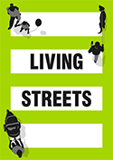
Living Streets

